Red Hat JBoss BPM Suite
Customer Evaluation Demo
(Use case: rules integration with BPM)

Eric D. Schabell
JBoss Technology Evangelist (Integration & BPM)
Table of Contents
Introduction 2
Setup and Configuration 2
Installation 2
JBoss Developer Studio Configuration 3
Start the JBoss BPM Suite Platform 4
Viewing Project in JBoss BPM Suite Business Central Console 5
Running the Demo 5
JBDS IDE demo 5

Introduction
This is a JBoss BPM Suite demo application setup guide for the Customer Evaluation Demo. The setup will create a fully installed and configured JBoss BPM Suite environment so that you can demo the project in all the available BPM components.

It will provide you with a JBoss Developer Studio project with unit tests to demo the project in the IDE. It will also provide a JBoss BPM Suite product configured with the demo for inspection in the web tooling called the business central admin console for business users.

This project was directly migrated from the previous version of JBoss BRMS 5.x and that project can be found for evaluation at https://github.com/eschabell/brms-customer-evaluation-demo.

Setup and Configuration

Installation
You first need to get the project by cloning it from the central location:

git clone git://github.com/eschabell/bpms-customer-evaluation-demo.git

Once downloaded, you will have the following folder structure:
- \bpms-customer-evaluation-demo
  - \installs – Initially empty, but will contain the JBoss BPM Suite platform downloads.
  - \projects – The project that comprise the demo.
  - \support – Additional supporting files used by the demo.
  - \target – Will be created by running init.sh. Contains the fully configured JBoss BPM Suite runtime server.
  - \docs – contains Demo Overview and Quick Start Guide along with demo images.
  - init.sh – Script to install and configure the run time server environment.
Next, download JBoss BPM Suite from the Red Hat Customer Portal (https://access.redhat.com/jbossnetwork).
Download JBoss BPM Suite:
- Under JBoss Enterprise Platforms, select the BPM Suite product.
- Select the version required as listed in the /installs/README file.
- Download Red Hat JBoss BPM Suite Deployable for EAP 6.1.0.

Now copy jboss-bpms-{$version}-deployable-eap6-x.zip, to the projects \installs folder. Ensure that this file is executable by running:

$ chmod +x <path-to-project>/installs/jboss-bpms-{$version}-deployable-eap6-x.zip

Download EAP 6 Platform:
- Under JBoss Enterprise Platforms, select the Application Platform product.
- Select version 6.1.1 in the Version field.
- Download JBoss Aplication Platform 6.1.1.

Now copy jboss-eap-6.1.1.zip, to the bpms-customer-evaluation-demo's installs folder. Ensure that this file is executable by running:

$ chmod +x <path-to-project>/installs/jboss-eap-6.1.1.zip

Lastly, from the bpms-customer-evaluation-demo folder, run the init.sh script:

$ ./init.sh

When the script completes you will have a new folder named jboss-eap-6.1, in the bpms-customer-evaluation-demo's target folder. The folder is a ready to run JBoss EAP 6 server with JBoss BPM Suite with the following modifications made:
- The erics accounts enabled (password: bpmsuite) in the application-roles.properties and application-users.properties file in bpms-customer-evaluation-demo/target/jboss-eap-6.1/jboss-as/standalone/configuration
- Adjusted server with copied new standalone.xml to bpms-customer-evaluation-demo/target/jboss-eap-6.1/jboss-as/standalone/configuration
- Copied over support/bpm-suite-demo-niogit project repository to bpms-customer-evaluation-demo/target/jboss-eap-6.1/jboss-as/bin/.niogit, this contains the git repository that the product will pick up on initial startup and can be reset with a fresh copy if needed.

JBoss Developer Studio Configuration
In this section, you will configure JBoss Developer Studio. Specifically you will add the JBoss BPM Suite platform server runtime environment and then import the project that makes up the JBoss BPM Suite Customer Evaluation Demo.
Important: It is assumed that you already have JBoss Developer Studio installed. This demo has been tested with JBoss Developer Studio 7
Launch JBoss Developer Studio
- Either select or switch to a new workspace by pointing to the bpms-customer-evaluation-demo/projects folder.
- If the Welcome to JBoss Developer Studio screen appears, dismiss it by click the Workbench arrow in the upper right.
Install Integration Tools for JBoss BPM Suite
- Select Help → Install New Software... and add Integration Tools update site:
https://devstudio.jboss.com/updates/7.0-development/integration-stack/
- Select JBoss Business Process and Rules Development & JBoss Integration and SOA Development (all sub-menu items will be selected) and proceed thru installation and restart JBoss Developer Studio to complete the installation. You will be told to restart JBoss Developer Studio for the changes to take effect, do this now.
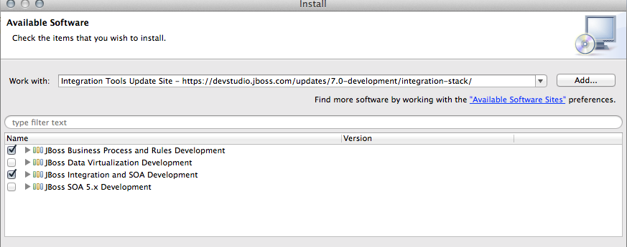
Detect and add a JBoss EAP 6.1 runtime environment
- Select Preferences from the Window menu.
- In the left hand side, expand JBoss Tools and then select JBoss Tool Runtime Detection
- Select the Add button and navigate to the bpms-customer-evaluation-demo/target folder, then select OK.
- The jboss-eap-6.1 runtime created earlier should have been found and selected. If so, select OK.
- Select OK again to close the Preferences dialog window.
Import Projects
- Select Import... from the File menu.
- Expand the Maven folder, and then select Existing Maven Projects.
- Select the Browse button to Select root directory, you should be in the bpms-customer-evaluation-demo/projects folder (if not, then navigate there) and then select OK.
- Make sure the project (customer-evaluation-demo) is selected and then select Finish.
- The project is now imported.

Start the JBoss BPM Suite Platform
In this section, you will start the server from within JBoss Developer Studio.
- Select the Servers view
If it is currently not open, select Show View --> Other... from the Window menu and search for the Servers view.
- You should see the jboss-eap-6.1 server you created earlier.
- Right click on jboss-eap-6.1 and select Start from the pop-up menu. In a few moments your JBoss Enterprise BRMS Platform will be running.

Viewing Project in JBoss BPM Suite Business Central Console
In this section, you will access and view the project assets in the JBoss BPM Suite Business Central console.
- Open up your Web browser of choice and navigate to http://localhost:8080/business-central
- Use the default credentials of erics/bpmsuite
- Select the Authoring pull down menu at the top right.
- From the Authoring list select Project Authoring to view the project assets
  - Initial view should be of the process itself, otherwise select the Business Processes → customereval to open the process in the designer.
  - View the single rule, select DRL → financerules to open in the viewer.
  - To view the projects data model, open the Data Modeler by selecting on the top right Tools → Data Modeler to find and examine the Person and Request objects that make up our business model.
  - The other items in the project can be viewed in the same fashion, left to you to explore, extend, and create new ones such as tests.
- Deploy the project by selecting the Tools → Project Editor from the top right, then in the Project view select the Build & Deploy button. You will be asked to save eventual changes, then see the successfully saved message in a green bar at the top along with Build Successful green bar.
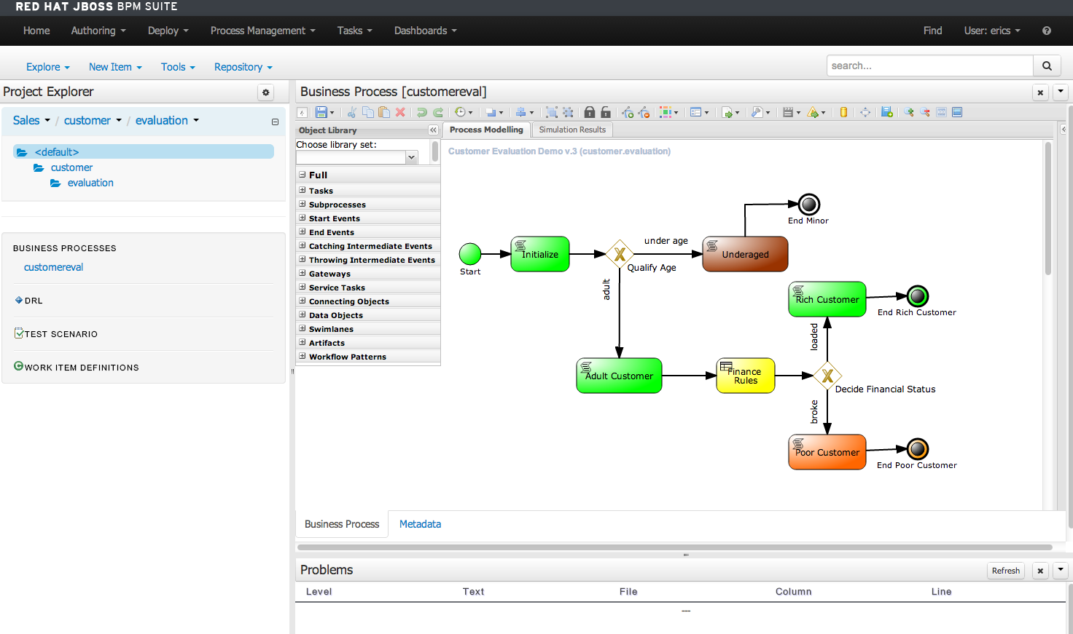

Running the Demo

JBDS IDE demo
You can demo the project in the JBoss Developer Studio by making use of the editors, running the provided unit tests and watching the console for logged (verbose) output. This unit test demonstrates the maven interaction that you can achieve with a JBoss BPM Suite project.

First you have to have started the JBoss BPM Suite as covered above and built the project so that a kjar will be built (a knowledge jar is just a maven jar artifact) that contains your rule, process, and model packaged up for development and deployment use.

This unit test in the development project shows how a dependency is added to the project pom file, that we can then pull in to develop our application against. We will pull in the dependency and then run the unit tests.
The following will run the demo process with four unit tests:
- Make sure the JBoss BPM Suite is running, that the project has been Build & Deployed.
- From within JBoss Developer Studio run the Maven Install command as shown in illustration 1, this will pull in the customer evaluation 1.0 dependency that is required as listed in the projects pom file.
- In case you missed the unit test running in step 2, select the file customer-evaluation-demo/src/test/java/CustomerEvaluationTest.java, right click, Run As..., JUnit Test.
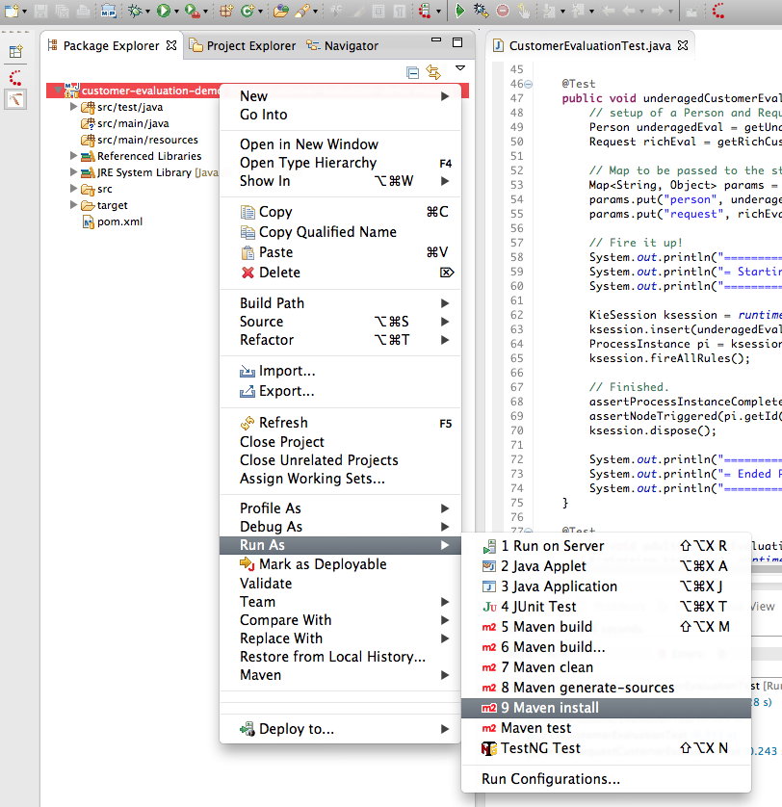Illustration 1: Running Maven Install on the project.
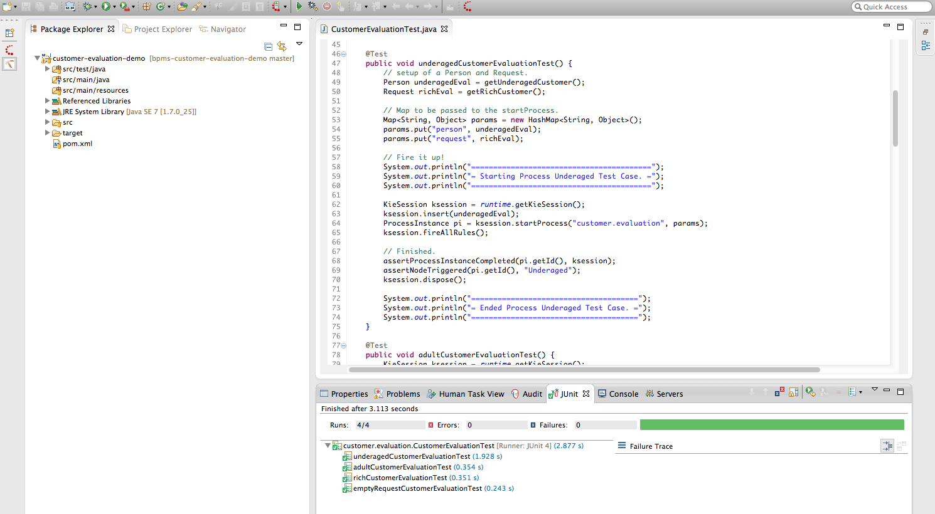Illustration 2: JBDS JUnit Tests
Your output should look something like illustration 2 and example output of the console logging:
Test 1
=========================================
= Starting Process Underaged Test Case. =
=========================================
Entering Initialize Node
Leaving Initialize Node
Gateway: Qualify Age
Gateway: Qualify Age
Entering Underaged Node
Detected and reporting invalid request.
Set validRequest to: false
Leaving Underaged Node
Process ended in End Minor Node.

Test 2
==========================================
= Starting Process Poor Adult Test Case. =
==========================================
Entering Initialize Node
Leaving Initialize Node
Gateway: Qualify Age
Gateway: Qualify Age
Entering Adult Customer Node
Detected and reporting valid request
Set validRequest to: true
Leaving Adult Customer Node
Entering Finance Rules Node
Under funded customer
Set Request invalid comment to: Poor customer.
Customer request= org.jbpm.evaluation.customer.Request@31
Leaving Finance Rules Node.
Gateway: Decide Financial Status
Determined request is NOT valid, heading to Poor Customer Node
Request validity reason is: Poor customer
Leaving Finance Rules Node.
Gateway: Decide Financial Status
Detected request is invalid, heading to Poor Customer Node
Request not valid reason is: Poor customer
Entering Poor Customer Node
Customer has amount: 2 in the bank.
Leaving Poor Customer Node
Process ended in End Poor Customer Node.

Test 3
==========================================
= Starting Process Rich Adult Test Case. =
==========================================
Entering Initialize Node
Leaving Initialize Node
Gateway: Qualify Age
Gateway: Qualify Age
Entering Adult Customer Node
Detected and reporting valid request
Set validRequest to: true
Leaving Adult Customer Node
Entering Finance Rules Node
Leaving Finance Rules Node.
Gateway: Decide Financial Status
Determined request is valid, heading to Rich Customer Node
Entering Rich Customer Node
Detected and reporting valid request
Customer has amount: 2000 in the bank.
Leaving Rich Customer Node
Process ended in End Rich Customer Node.

Test 4
=============================================
= Starting Process Empty Request Test Case. =
=============================================
Entering Initialize Node
There as no evaluation objects defined, adding default ones for demo purposes.
Leaving Initialize Node
Gateway: Qualify Age
Gateway: Qualify Age
Entering Underaged Node
Detected and reporting invalid request.
Set validRequest to: false
Leaving Underaged Node
Process ended in End Minor Node.

